OTHER AIRYX PRODUCTS
SkySpec Instrument Series
accurate AND FLEXIBLE SPECTRAL observations of scattered and direct sun light
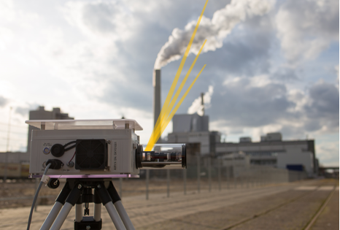  SkySpec Compact | 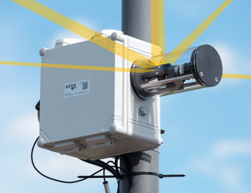  SkySpec 1D | 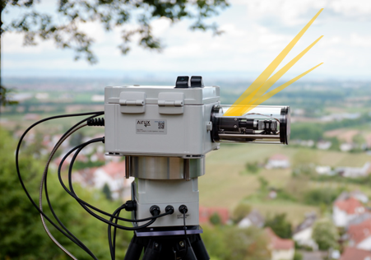  SkySpec 2D
The SkySpec instrument series performs fast, flexible and reliable atmospheric observations with the passive DOAS (Differential Optical Absorption Spectroscopy) method; according to VDI standard 4212. Ultra violet and visible radiation spectra of direct and scattered sunlight in multiple viewing directions are acquired and analysed to obtain information on the spatial distributions of various trace gases (e.g., NO₂, O₃, SO₂, formaldehyde, H₂O, HONO, IO, BrO, Glyoxal) and aerosols in the troposphere as well as the stratosphere. Also, other high precision spectroscopic applications are possible (e.g., surface reflection spectroscopy).

Open-path active remote sensing instrument
FAST AND ACCURATE SPECTRAL TRACE GAS MEASUREMENTS USING ACTIVE SPECTROSCOPY

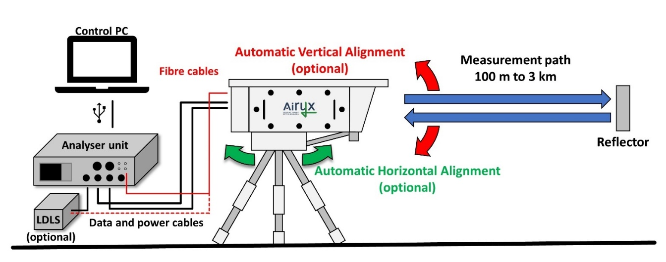
Scheme of the Open-path instrument setup. Besides standard high Power LEDs, a broadband Laser-Driven Light Source (Xe-lamp) is available.
The Airyx open-path remote sensing instrument allows to monitor a wide range of atmospheric trace gases (NO₂, SO₂, O₃, HCHO, HONO, H₂O, BrO, OClO) based on the method of Differential Optical Absorption Spectroscopy (DOAS). Light emitted by high power LEDs (centred at 280, 325, and 365 nm wavelength) covering the UV/VIS range from 280 to 380 nm are coupled into a telescope and sent through the atmosphere along light paths of lengths between several 100 m and several km. Optionally, a high-power broadband light source (LDLS) is available extending the spectral range and the maximum measurement path length. The instrument measures the average concentration along the path with high precision (sub ppb range, depending on path length) and high time resolution of a few seconds.

FOR MORE INFORMATION ABOUT INSTRUMENTS AND SERVICES, VISIT airyx.de!
ICAD IN SITU ANALYSERS
PATENTED, DIRECT NO₂ AND / or HONO DETECTION - NITROGENMONOXIDE (NO) MEASUREMENT VIA O₃ TITRATION CONVERTER - HIGH PRECISION – EASY OPERATION - CALIBRATION NOt REQUIRED

  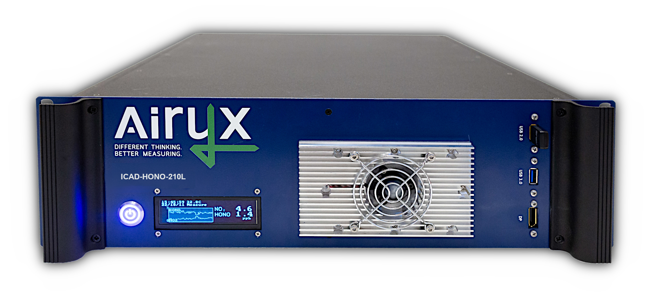 | 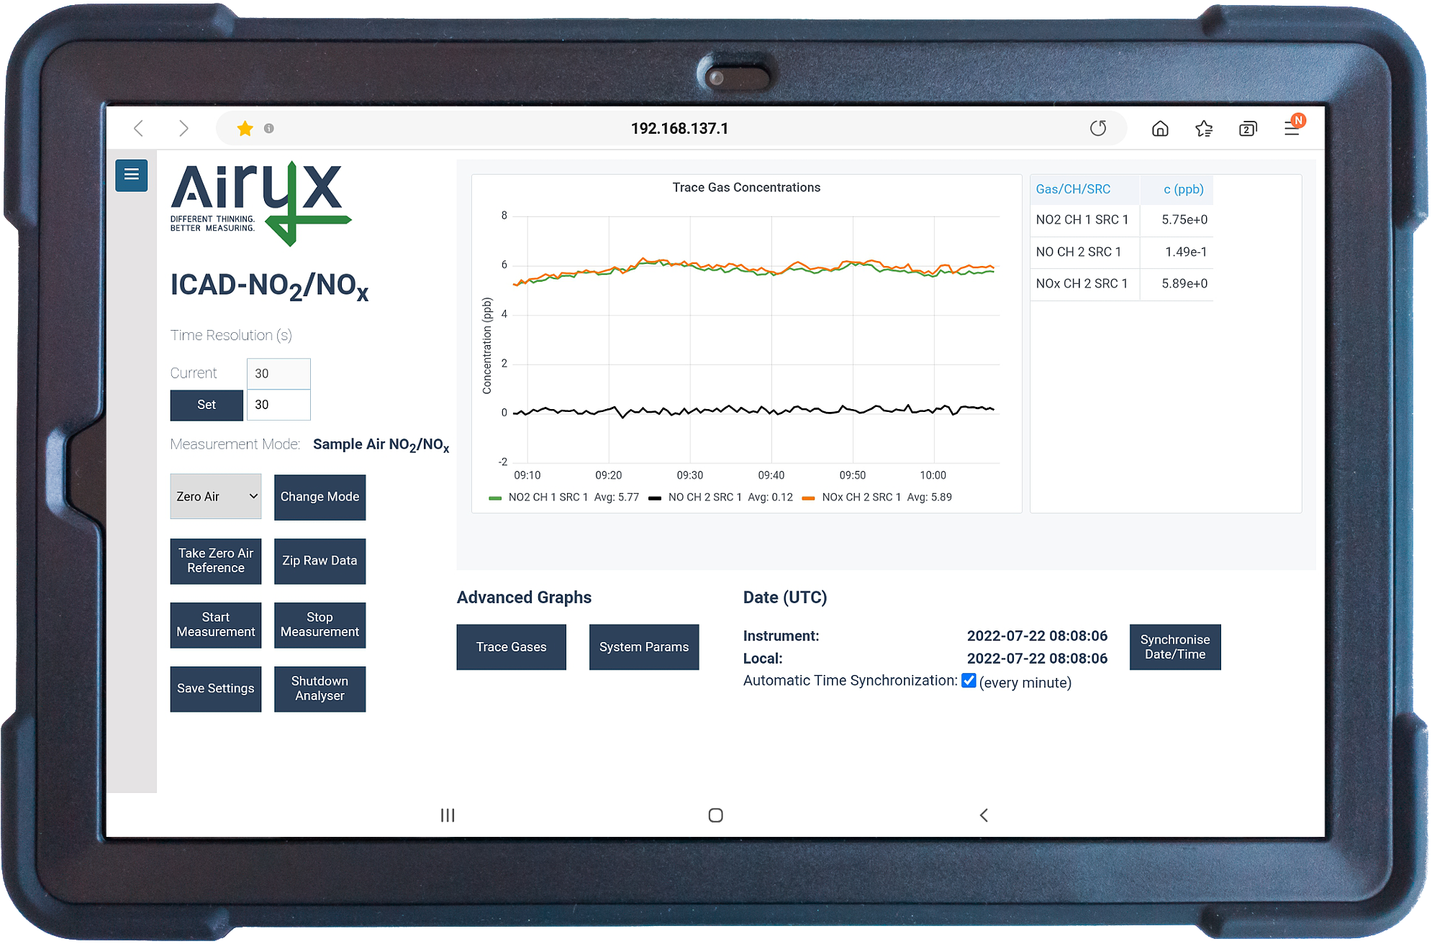  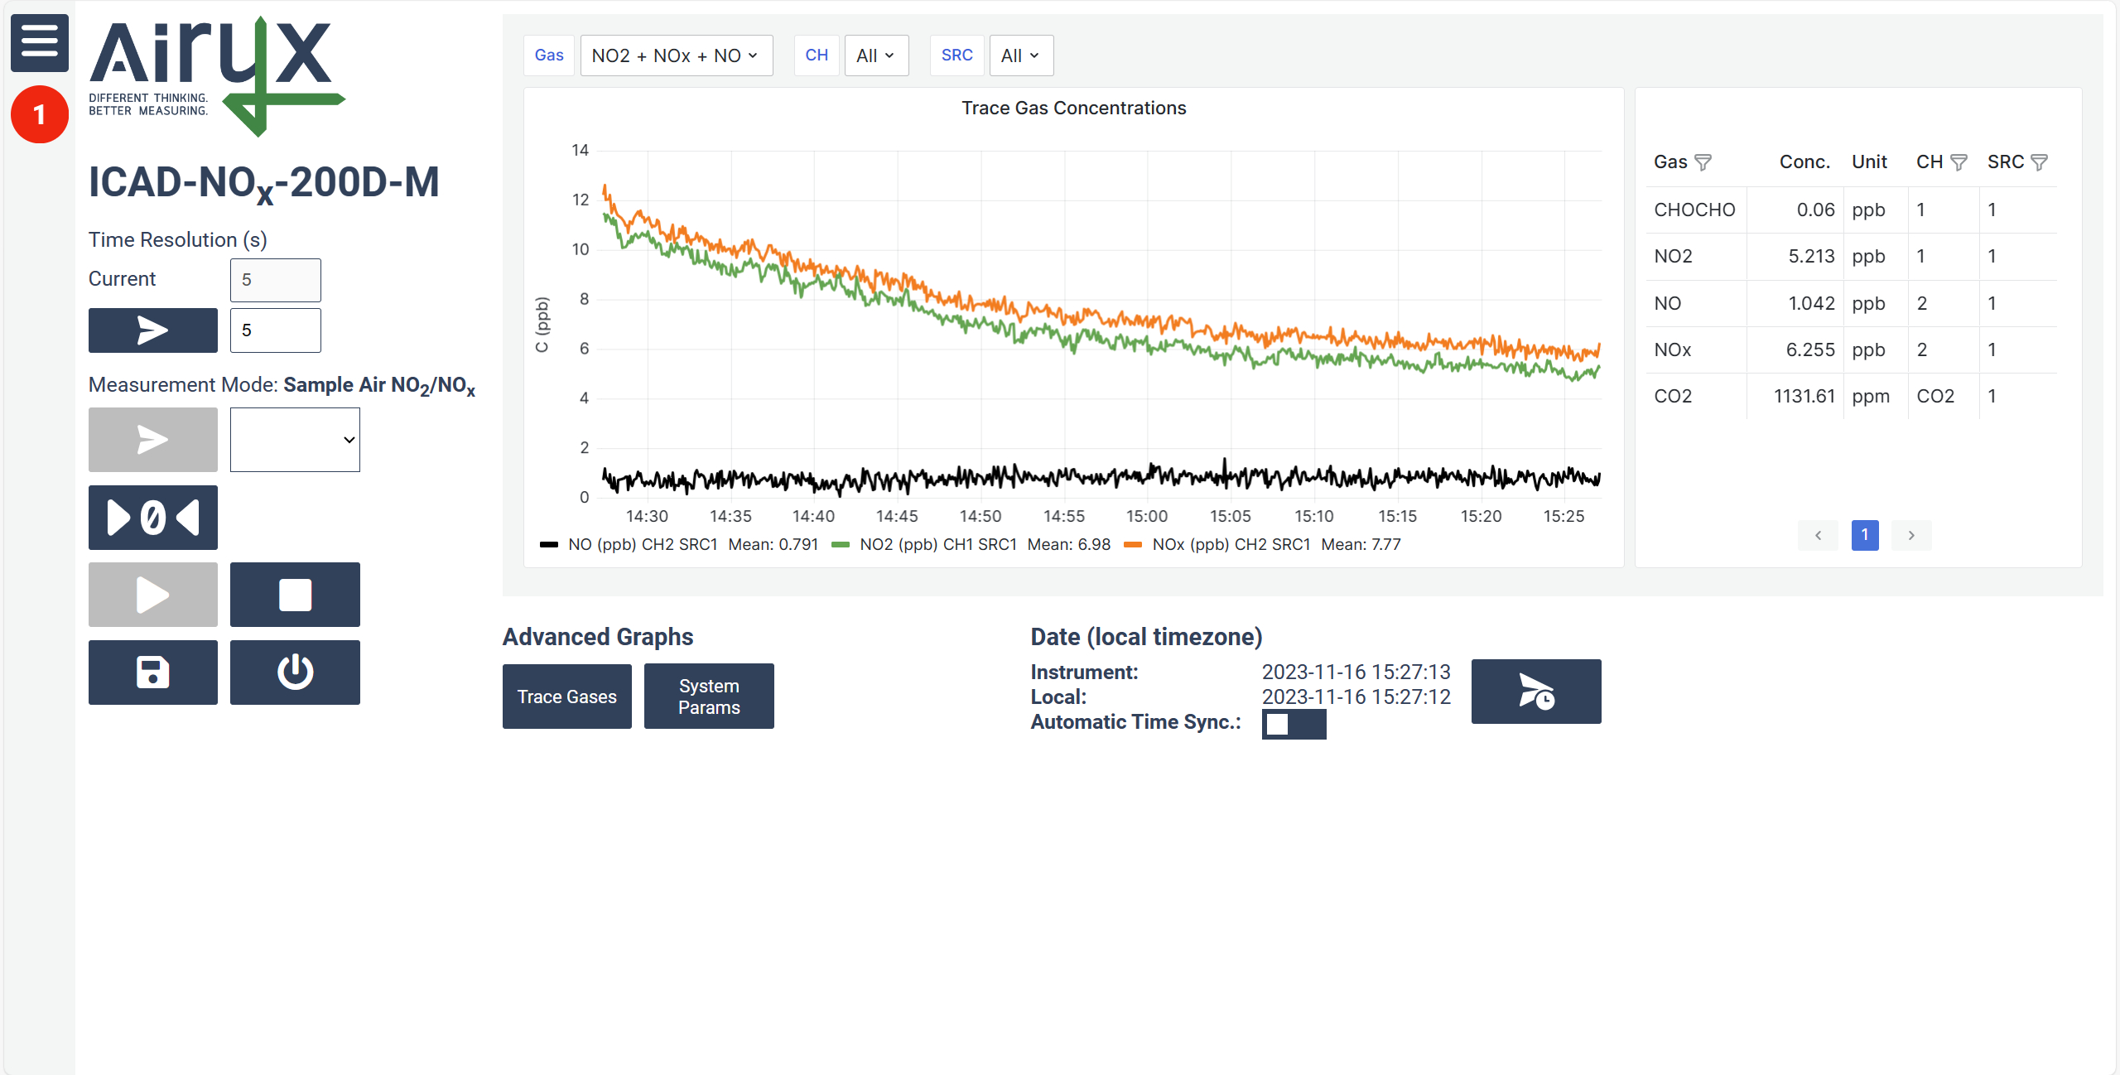 | 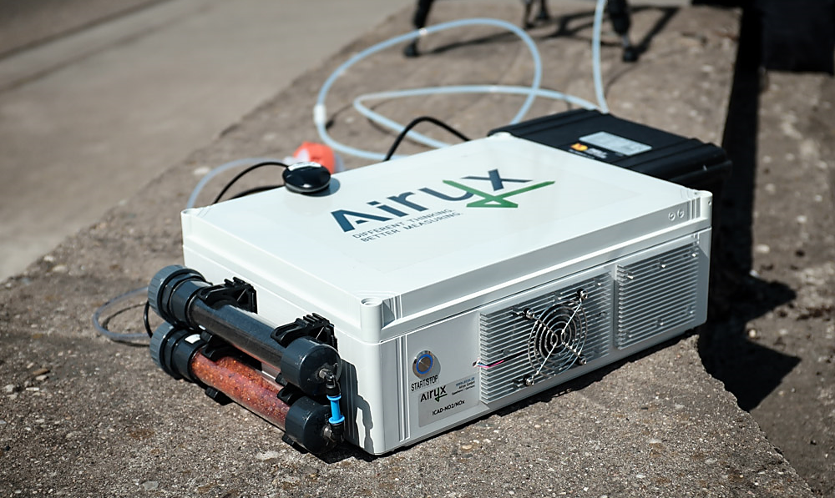

NO₂/NO/HONO measurement - ppt range - high time resolution - low power consumption


High Sensitivity, LARGE dynamic range & Mobility
The ICAD features typical advantages of high accuracy, instrumental stability, long maintenance intervals and low consumables. Further, the high dynamic range allows measurements from high polluted conditions e.g., at high traffic roads or industrial monitoring to very low concentrations in clean environments. If even ultra-low NO_{x} concentrations down to 15 ppt are of interest, the special ICAD high-grade versions “*L” are the perfect tool. The measurement can easily be controlled with a tablet connected to the ICAD via WiFi.

WORK SpaCE NO₂ / NO_{x} Monitoring or INDUSTRIAL monitoring
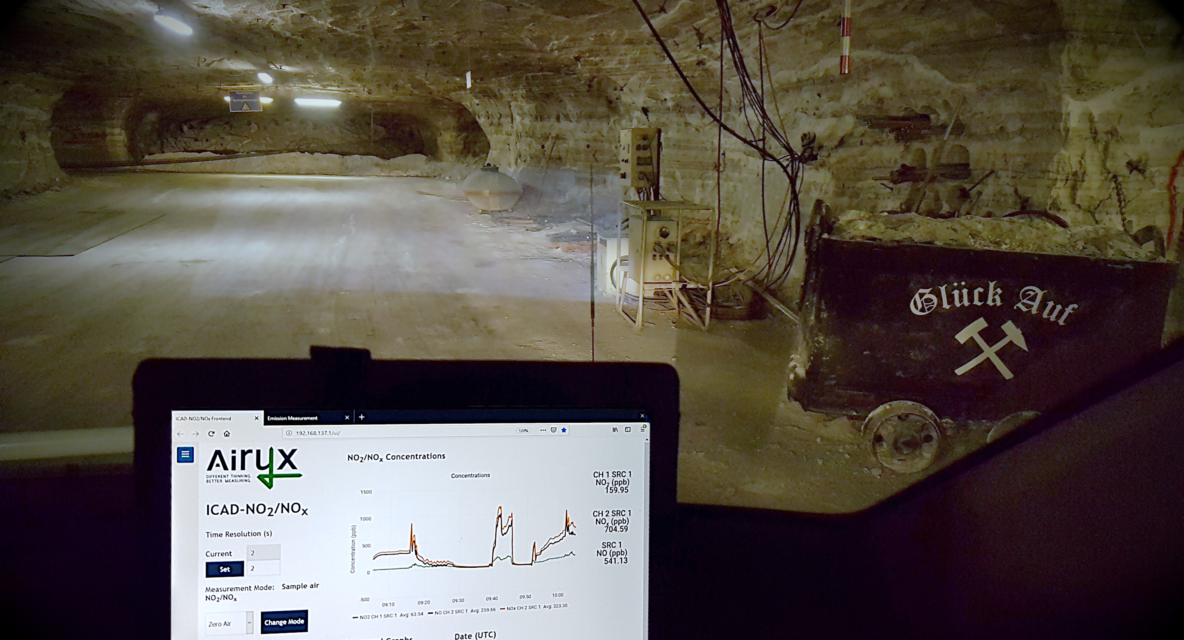
The high mobility, rugged design, and low maintenance effort make ICAD instrument the ideal instrumentation for reliable monitoring NO_{x} levels in workplace environments such as mines, constructions site or industrial production places. Further, ICAD instruments can be applied to measure and monitor the NO_{x} emissions of industrial machines. Multiple data interfaces enable optional integration of ICAD instruments with industrial processes.

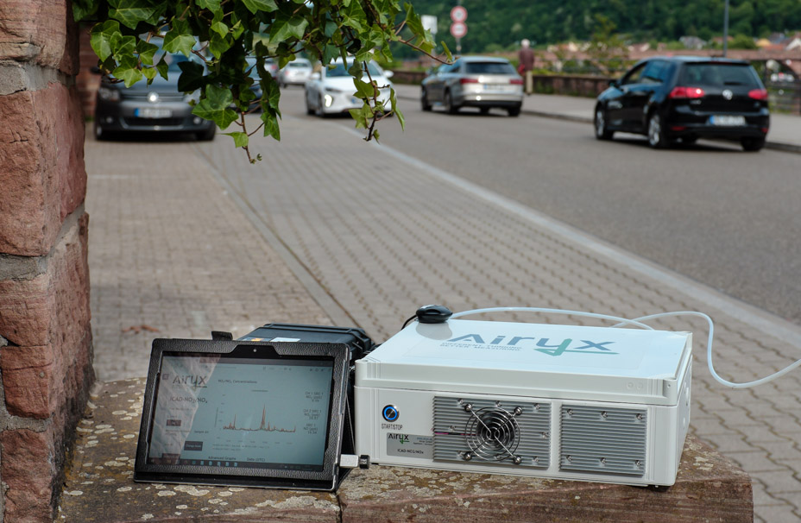

Mobile measurements
The low power consumption, compact size, moderate weight and insensitivity to vibrations allow easily mobile measurements at different locations. The short set-up and warm-up time gives a lot of flexibility. Customized, ICAD versions for applications on drones are also available.
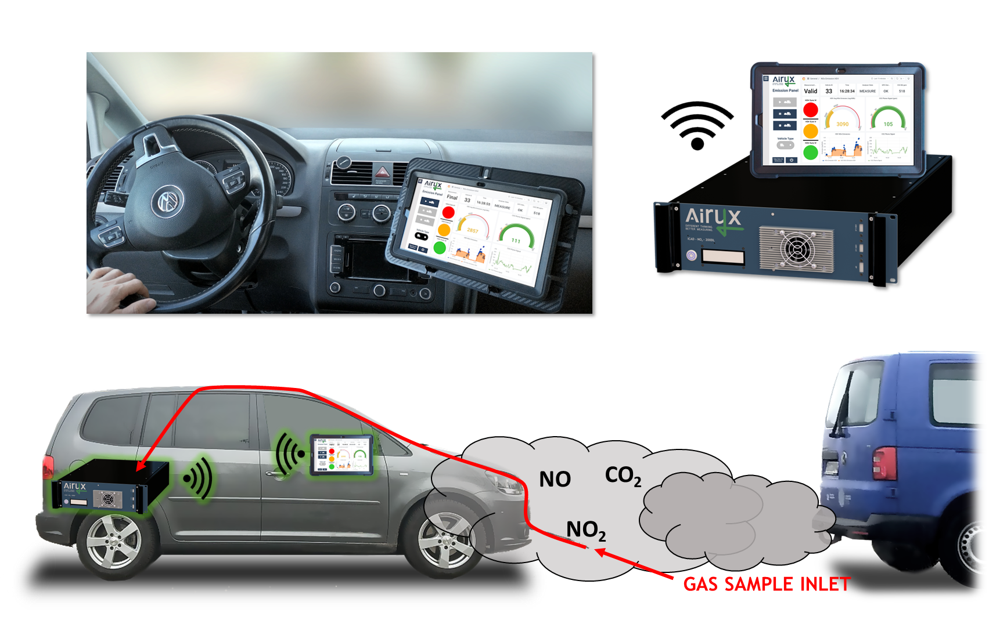
mobile applications – On-road real driving emissions
ICAD for emissions “*E” (equipped with additional internal CO₂ sensor) allow on-road real driving emissions via the so-called Plume Chasing method. A vehicle with the ICAD, follows target vehicles to measure the gases in the diluted plume. Within seconds the system derives the specific NO_{x} emission signature from the vehicle. In short times, high emitting vehicles due to defects or exhaust manipulations are identified. The tool allows authorities to enhance inspection efficiency or researchers to perform a vehicle emission screening.

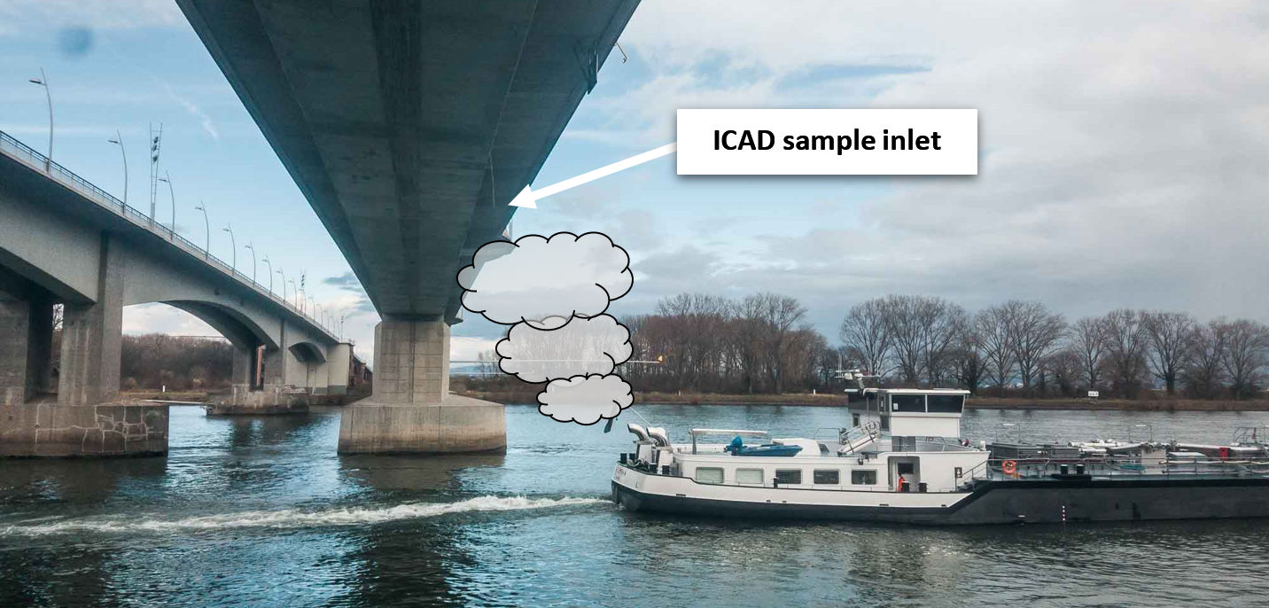
flexible deployment – EXTENDED application
The fast response time of the ICAD instrument enables monitoring and assignment of NO_{x} emissions from water vehicles by placing the instrument near water ways (e.g., at bridges or at the shoreline). With the ICAD emission configuration, NO_{x} emission factors (mg NO_{x}/kWh) are similar derived like for the real driving application. The calculation is independent from dilution of exhaust gases and thus, influence of meteorology.

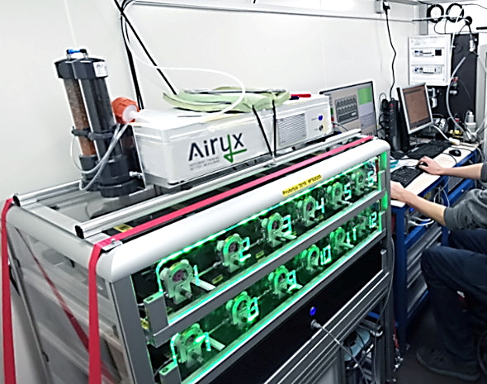
No Drifts, no cross-interferences
The selective detection of NO₂, NO_{x} or HONO, high measurement sensitivity and negligible drift makes the ICAD perfectly suitable for stationary air quality monitoring as well as scientific studies of chemical processes, e.g., atmospheric studies or simulation experiments. Further, the absence or cross-interferences to other gas species, enables measurements also of complex mixture (e.g., containing high concentration of CO₂, N₂O, H₂O or hydrocarbons).

Technique And Features

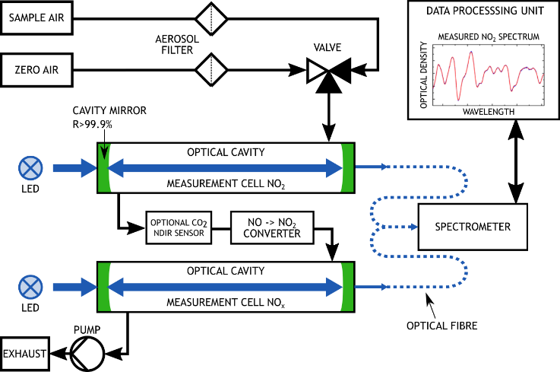 | - Direct measurement by differential absorption spectroscopy  - High sensitivity and accuracy by use of ICAD algorithm (insensitive to intensity variations and aging of light sources)  - No cross-interference, spectral separation from other gases like water vapour (H₂O), Glyoxal (C₂H₂O₂), oxygen (O₂)  - NO₂ / HONO calibration gases not required; no pre-drying of sample air required  - High dynamic detection range of low ppt to ppm  - Fast response time of 1 seconds  - Optional internal CO2 extension for combustion emission measurements (e.g., vehicle on-road measurement, Plume Chasing)  - Remote access with any Wi-Fi device. GUI for easy operation. Multiple data interfaces.  - Graphical system health table for easy and fast on-board diagnosis.
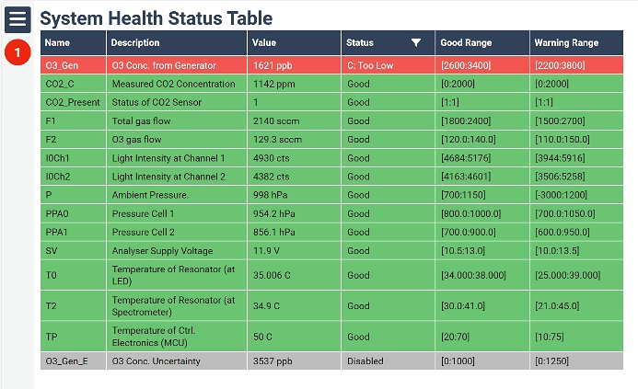

ICAD model overview
 | NO2-210 | NOx-210D | NOx-210DE | NO2-210L | NOx-210DL | HONO/NO2-210L
Detectable gases | NO₂ | NO₂ / NO | NO₂ / NO / CO₂ | NO₂ | NO₂ / NO | HONO / NO₂
Range | 5 ppm | 5 / 5 ppm | 5 / 5 / 2000 ppm | 2 ppm | 2 ppm / 2 ppm | 0.5 / 2 ppm
Limit of detection at  2s, 30s, 300s in ppt | 350,100,30 ppt | 350,100,30 ppt | 350,100,30 ppt  CO₂: 4 ppm | 200,50,15 ppt | 200,50,15 ppt | HONO: 500,120,40 ppt  NO₂: 600,150,50 ppt
Precision (1σ) at  2s, 30s, 300s in ppt | 175,50,15 ppt | 175,50,15 ppt | 175,50,15 ppt  CO₂: 2 ppm | 100,25,8 ppt | 100,25,8 ppt | HONO: 250,60,20 ppt  NO₂: 300,75,25 ppt
Available also as mobile “M”-version |  |  |  | 

Icad SPECIFICATIONS
Detection of NO₂, HONO | Direct spectroscopic measurement | Weight 19” Rack | < 12 kg (depending on config)
Detection of NO (NO_{x}) | By conversion to NO₂ | Weight “M” version | < 10 kg (depending on config)
Response Time (10% to 90%)^{*2} | 2s at 1 l/min or 1s at 2 l/min | Power consumption | Less than 40 W at 12 V (typ.)
Zero drift | Less than 0.1 ppb/month^{*3} | Start-up time | Less than 1 min (typ.)
Sample flow | 1 to 2 l/min | Temp. range of operation | -10 to +25°C (+40°C with cooling option)
Time resolution | 1s to 60 s temporal averaging | Temperature sensitivity | Less than 0.01 ppb/°C
Calibration for NO₂ / HONO | Via spectroscopic data, gas-free^{*4} | Cross sensitivity | No significant cross sensitivity^{*5}
Path length characterization | Gas free ICOM method,  Helium (optional, every 1 to 2 years) | Mech. stability | Insensitive to vibrations
Path length characterization | Gas free ICOM method,  Helium (optional, every 1 to 2 years) | Consumable gases | No gases needed for operation
Path length characterization | Gas free ICOM method,  Helium (optional, every 1 to 2 years) | Other detectable gases | Glyoxal^{*6} (respected by spectral analysis)
Housing Size 19” Rack | 43.8 x 13.3 (3HU) x 43.5 cm³ (WHD) | Processing unit | Internal embedded PC (WIN10)
Housing Size 19” Rack “L” | 43.8 x 13.3 (3HU) x 66.5 cm³ (WHD) | Data communication | LAN/WiFi/RS232/M2M/OPCUA; Bayern-Hessen Protocol; Voltage/Current Output
Housing Size “M” | 40.0 x 13.3 (3HU) x 30.0 cm³ (WHD) | Data communication
[*1] Custom specifications with different measurement range are possible. By reducing the measurement range better precision and LOD can be achieved. [*2] Response: Different measurement cell types are available, allowing different response times. [*3] Upper limit. Drift is negligible due to regularly automated reference measurements. [*4] Literature absorption data for target gas is used for gas quantification. [*5] No significant spectroscopic cross sensitivity found for: water, ozone, Glyoxal, Carbon Oxides, Methane, Formaldehyde, Hydrogen, Sulphide, Sulphur Dioxide, Chlorine, Chlorine Dioxide, Hydrogen Cyanide, Hydrogen Chloride, Phosphine, Hydrogen, Ammonia, Acetylene, Nitromethane, Ethylene, Ethanol, Methyl Mercaptan, Ethyl Mercaptan. [*6] For NO2-210 and NOx-210 models.

ADVANTAGES

Benefits | Innovation
High measurement accuracy | - Series 210 Improvement: Enhanced accuracy at higher concentrations  - Series 210 Improvement: Enhanced time resolution down to 1s  - Direct spectroscopic gas measurement  - High sensitivity, low measurement error  - Fast measurement response  - No zero-point or calibration drift, 100% reproducibility, no interferences  - No sample pre-dryer needed
Simple and low costs operation | - NO₂ / HONO calibration gas not required  - Parallel NO measurement (with ozone titration converter)  - No consumable gases needed  - Robust setup, long lifetime
Flexible application | - Series 210 Improvement: System Health GUI for fast on-board diagnosis  - Series 210 Improvement: Easy adjustment of span calibration in GUI  - High stability (not sensitive to shocks, vibration, temperature)  - Compact design, mobile application  - Low power consumption and 12 V operation  - Data Interfaces: WiFi, LAN, Machine2Machine, RS232, Analogue Volt./Cur.  - Internal memory for up to 2 years of data

Patents: DE102015000423; EP3329251; US15/748,923; China ZL201680057099.6

