ICAD HONO-NO₂ Analyzer SERIES 210
Patented, fast, accurate and direct HONO and No₂ Detection

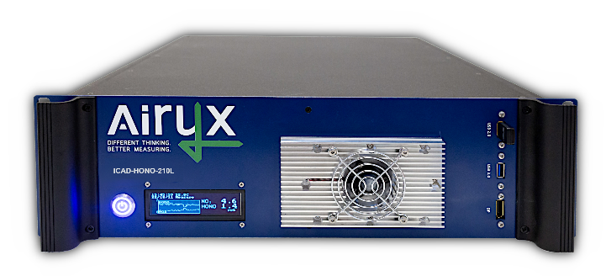  ICAD-HONO/NO2-210L series featuring 19" rack housing and OLED display. |       WI-FI  LOW MAINTENANCE  LOW POWER CONSUMPTION  DIRECT HONO & NO₂ DETECTION  - Iterative Cavity DOAS (ICAD) spectroscopy  - High resolved spectroscopic HONO & NO₂ detection from ~350 to 390nm  - No observed interferences, e.g. to water, NOx, HCHO O₂  - No sample drying, e.g. Nafion tubing, required  - No chemicals or gases required  LONG-TERM STABILITY AND ROBUSTNESS  - Insensitive to temperature and vibrations  - Independent from absolute light source intensity  - No zero-point drift, integrated zero measurement  EASY SET-UP AND OPERATION, LOW MAINTENANCE  - No gas calibration required, minimal maintenance effort  - Controllable via Wi-Fi devices (PC, tablet, smartphone)  - Multiple data communication protocols  - 19” rack  - Sustainable: Long life time, low power consumption  SERIE 210 NEW FEATURES  - System health GUI and on-board diagnosis  - Easy adjustment of span calibration in GUI  - Enhanced time resolution of 1 second  - Improved long term stability
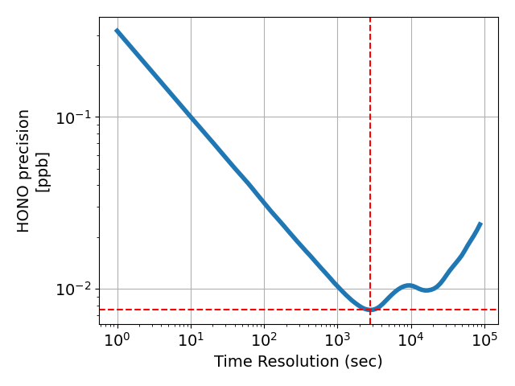
2800 sec
7.5 ppt
Time scaled modified Allan deviation for HONO precision. Note: Detection limits are defined as twice the modified Allan deviation values.
Patents: EP3329251; D502016003239.4; GB3329251; FR3329251; US10473583B2; ZL201680057099.6; DE102015000423 (pending); EP325928; D502016014735.3; GB3325928; FR3325928

 | 
ICAD Product webpage | Contact Airyx

GRAPHICAL USER INTERFACE AND ON-BOARD DIAGNOSIS |  | MEASUREMENT PRINCIPLE AND GAS FLOW
The Graphical User Interface provides easy operation and quick access to advanced functions and data time series. The ICAD can be accessed and controlled by any Wi-Fi device (PC, tablet, smartphone) without additional software/apps required. A comprehensive system health table shows the health status of critical sensor data (e.g. gas flow, supply voltage, temperature) for easy and fast on-board diagnosis. |  | ICAD instruments are based on optical resonators which provide here long absorption paths of up to 3 km for precise HONO and NO₂ detection especially at low concentrations. Gas concentrations are derived by patented Iterative Cavity DOAS (ICAD) spectroscopy between ~350 to 390nm. Below, the measurement scheme is shown.
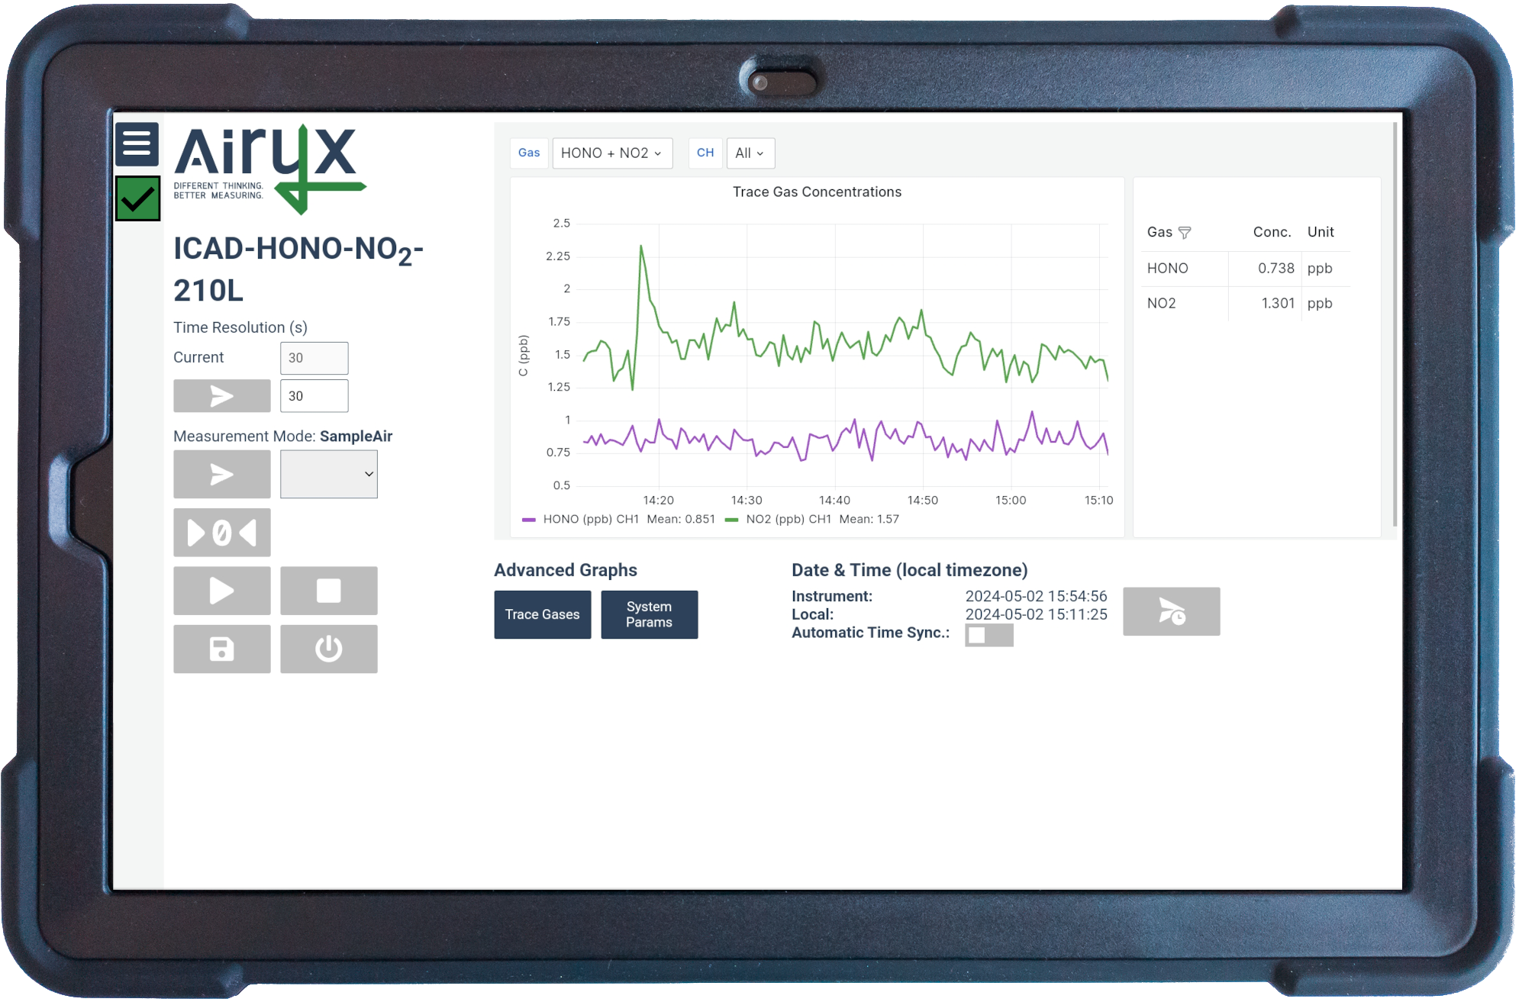 |  | 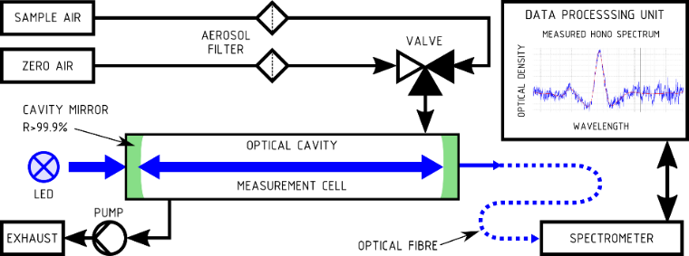

INSTRUMENT Specifications
 |  | HONO |  | NO₂ |  | Other detectable gases | CO₂ (optional NDIR sensor)
Measurement range¹ |  | 0 – 500 ppb |  | 0 – 2000 ppb |  | Mechanical stability | Insensitive to vibrations
Limit of det.¹ (2σ) at 60 sec |  | 0.08 ppb |  | 0.16 ppb |  | Power consumption | Less than 40 W at 12 V (typ.)
Precision (1σ) | at 1 sec | 0.3 ppb |  | 0.6 ppb |  | Start-up time | Less than 1 min (typ.)
Precision (1σ) | at 60 sec | 0.04 ppb |  | 0.08 ppb |  | Start-up time
Zero Drift² ppb / month |  | < 0.2 |  | < 0.3 |  | Temp. range of operation | -10 to +40°C
Detection of NO₂ / HONO |  | Direct spectroscopic measurement |  |  |  | Temperature sensitivity | Less than 0.01 ppb/°C
Response time (10% to 90%) |  | 1 sec at 2 l/min (flow adjustable) |  |  |  | Cross sensitivity | No significant cross sensitivity⁵
Time resolution |  | 1 sec minimum temporal averaging |  |  |  | Weight | Less than 12 kg (depending on config)
Sample flow |  | 1 to 2 l/min |  |  |  | Consumable gases | No gases/ chemicals needed for operation
Path length characterization |  | Helium (every 1 to 2 years, optional) or NO₂ reference measurement or  Gas free ICOM³ method |  |  |  | Dimensions  W x H x D | 19” rack  housing | 43.8 x 13.3 (3HU) x 66.5 cm
Calibration |  | HONO or NO₂ calibration gas not needed⁴; |  |  |  | Data communication | LAN/Wi-Fi/RS232/M2M/OPCUA; Bayern-Hessen Protocol; Volt./Current Output
 |  |  |  |  |  | Processing unit | Internal embedded PC, with data analysis and measurement software

[1] Custom configurations / measurement ranges available. By reducing the measurement range better precision and LOD can be achieved.
[2] Upper limit. Regularly automated zero measurement reduce measurement noise and guarantee also a negligible zero drift.
[3] ICOM (upcoming with software update): Integrated Calibration by means of optical Modulation. Patented gas free calibration method allows consumable free, automatic path length monitoring and calibration of ICAD measurement cells. Patents: EP325928; D502016014735.3; GB3325928; FR3325928
[4] Literature absorption data for HONO and NO₂ is used for gas quantification.
[5] No significant spectroscopic cross sensitivity to: Carbon oxides, Formaldehyde, Ozone, Methane, Hydrogen, Sulphide, Sulphur dioxide, Chlorine, Chlorine dioxide, Hydrogen cyanide, Hydrogen chloride, Phosphine, Hydrogen, Ammonia, Acetylene, Nitromethane, Ethylene, Ethanol, Methyl mercaptan, Ethyl mercaptan.

