ICAD NO₂-NO_{x}-NO Analyzer SERIES 210DL
Patented, fast, accurate and direct Nitrogen Dioxide Detection

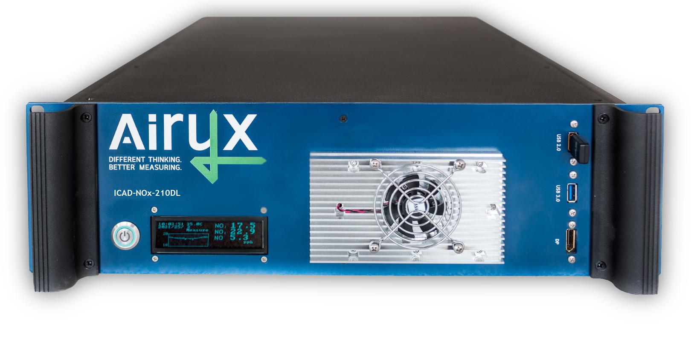  ICAD-NOx-210DL series featuring 19" rack housing and OLED display. |       WI-FI  LOW MAINTENANCE  LOW POWER CONSUMPTION  DIRECT NO₂ DETECTION  - Iterative Cavity DOAS (ICAD) spectroscopy  - High resolved spectroscopic NO₂ detection from 430 to 480 nm using fingerprint of NO₂ spectrum  - No observed interferences, e.g. to water, glyoxal, Ozone  - No sample drying, e.g. Nafion tubing, required  NO_{x} MEASUREMENTS BY INTERNAL CONVERSION  - Patented, NO_{x}-free ozone generator for NO conversion  - Dual measurement cells for parallel NO₂ and NO detection  LONG-TERM STABILITY AND ROBUSTNESS  - Insensitive to temperature and vibrations  - Independent from absolute light source intensity  - No zero-point drift, integrated zero measurement  EASY SET-UP AND OPERATION, LOW MAINTENANCE  - No gas calibration required, minimal maintenance effort  - Controllable via Wi-Fi devices (PC, tablet, smartphone)  - Multiple data communication protocols  - 19” rack  - Sustainable: Long life time, low power consumption  SERIE 210 NEW FEATURES  - System health user interface and on-board diagnosis  - Easy adjustment of span calibration in user interface  - Enhanced time resolution of 1 second  - Improved accuracy at high concentrations  - Improved long term stability
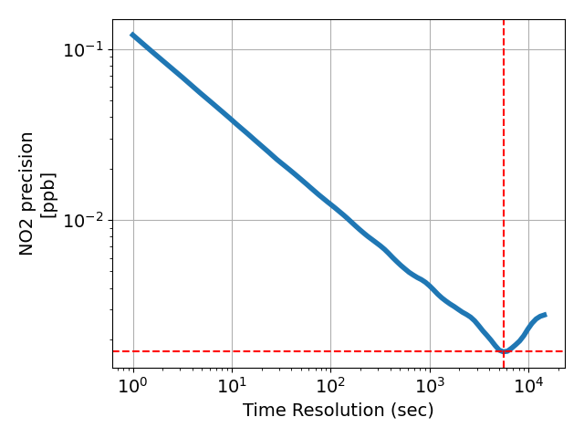
5600 s
1.7 ppt
Time scaled modified Allan deviation for NO₂ precision. Note: Detection limits are defined as twice the modified Allen deviation values.
Patents: EP3329251; D502016003239.4; GB3329251; FR3329251; US10473583B2; ZL201680057099.6; DE102015000423 (pending); EP325928; D502016014735.3; GB3325928; FR3325928

 | 
ICAD Product webpage | Contact Airyx

GRAPHICAL USER INTERFACE AND ON-BOARD DIAGNOSIS |  | MEASUREMENT PRINCIPLE AND GAS FLOW
The Graphical User Interface provides easy operation and quick access to advanced functions and data time series. The ICAD can be accessed and controlled by any Wi-Fi device (PC, tablet, smartphone) without additional software/apps required. A comprehensive system health table shows the health status of critical sensor data (e.g. gas flow, supply voltage, temperature) for easy and fast on-board diagnosis. |  | ICAD instruments are based on optical resonators which provide here long absorption paths of up to 4 km for precise NO₂ / NO_{x} detection especially at low concentrations. Gas concentrations are derived by patented Iterative Cavity DOAS (ICAD) spectroscopy between ~430 to 480nm. Below, the measurement scheme incl. additional NO to NO₂ converter for NO_{x} measurement and optional CO₂ sensor is shown.
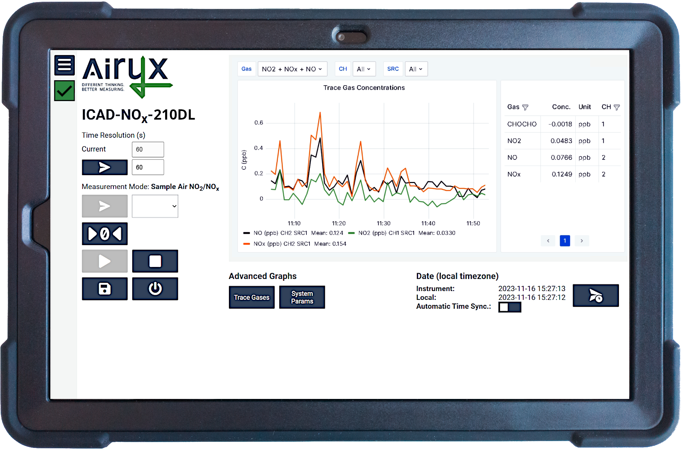 |  | 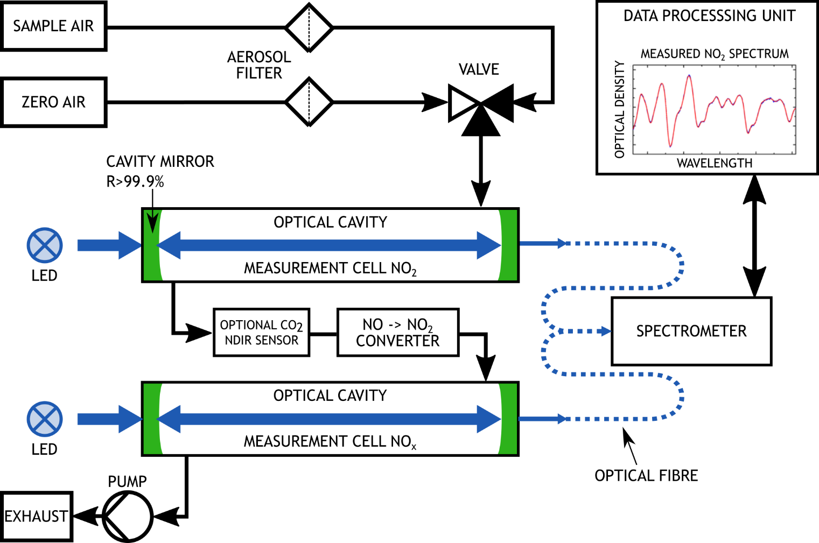

INSTRUMENT Specifications
Measurement range¹ | 0 – 2000 ppb |  | Other detectable gases | Glyoxal, CO2 (optional NDIR sensor)
Time resolution | 1 sec minimum temporal averaging |  | Mechanical stability | Insensitive to vibrations
Limit of detection¹ (2σ) | 0.03 ppb at 60 sec |  | Power consumption | Less than 40 W at 12 V (typ.)
Precision (1σ) | 0.12 ppb at 1 sec |  | Processing unit | Internal embedded PC, with data analysis and measurement software
Precision (1σ) | 0.02 ppb at 60 sec |  | Processing unit
Detection of NO2 | Direct ICAD spectroscopy |  | Temp. range of operation | -10 to +40°C
Detection of NO_{x} / NO | By conversion to NO2 |  | Temperature sensitivity | Less than 0.01 ppb/°C
Response time (10% to 90%) | 1 sec at 2 l/min (flow adjustable) |  | Cross sensitivity | No significant cross sensitivity⁵
Zero Drift | Less than 0.1 ppb/month² |  | Weight | Less than 12 kg (depending on config)
Sample flow | 1 to 2 l/min |  | Consumable gases | No gases needed for operation
Path length characterization | Helium (every 1 to 2 years, optional) or NO₂ reference measurement or  Gas free ICOM³ method |  | Dimensions  W x H x D | 19” rack  housing | 43.8 x 13.3 (3HU) x 66.5 cm
Calibration | NO₂ calibration gas not needed⁴;  NO gas for converter calibration above 1000 ppb (~every 12 months) |  | Data communication | LAN/Wi-Fi/RS232/M2M/OPCUA; Bayern-Hessen Protocol; Volt./Current Output
Calibration |  |  | Start-up time | Less than 1 min (typ.)
Model variations | ICAD-NO2-210L  ICAD-NOx-210DL | (NO₂ only)  (NO + NO₂)

[1] Custom configurations / measurement ranges available. By reducing the measurement range better precision and LOD can be achieved.
[2] Upper limit. Regularly automated zero measurement reduce measurement noise and guarantee also a negligible zero drift.
[3] ICOM (upcoming with software update): Integrated Calibration by means of optical Modulation. Patented gas free calibration method allows consumable free, automatic path length monitoring and calibration of ICAD measurement cells. Patents: EP325928; D502016014735.3; GB3325928; FR3325928
[4] Literature absorption data for NO₂ is used for gas quantification.
[5] No significant spectroscopic cross sensitivity to: Carbon oxides, Formaldehyde, Ozone, Methane, Hydrogen, Sulphide, Sulphur dioxide, Chlorine, Chlorine dioxide, Hydrogen cyanide, Hydrogen chloride, Phosphine, Hydrogen, Ammonia, Acetylene, Nitromethane, Ethylene, Ethanol, Methyl mercaptan, Ethyl mercaptan.

